Net Worth versus Number of Trades: all students.
r² = 0.77. Line predicts 77% of the relationship.

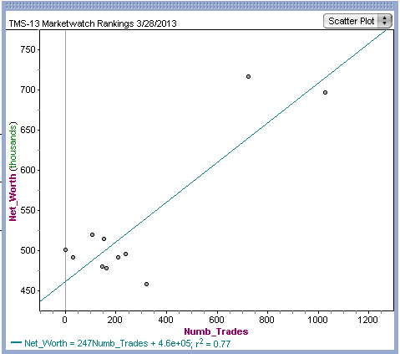

Remove top two students (outliers). No relationship between Number of Trades and Net Worth.

