Did Walter choke at the hot dog eating playoffs?

By Joe Dog 9/23/2013

Hot dog competitions are becoming more and more common. We are considering starting one at our school. We chose the making or missing the 50 dogs/50 minutes requirement. Did Walter’s ability go down in the playoffs?

We got the data from www.hotdogcentral.com.

 | Made | Missed
Regular season | 270 | 30
Playoffs | 20 | 5

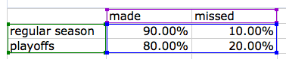

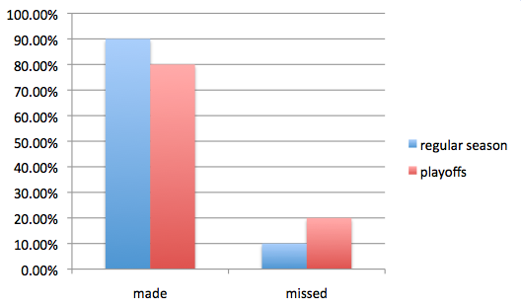
Fig. 1. Walters “made” and “missed” percentages in regular season and playoffs.

Was his lower performance in the playoffs due to random chance?

We used the textbook website to simulate 100 playoffs assuming that the ability of Walter was his regular season performance of 90%. We run 25 games per each simulated season.

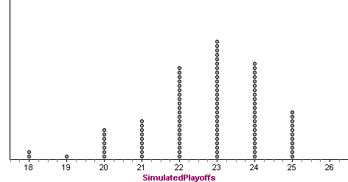
Fig 2. Simulation results. Each dot represents a simulated 25-game playoff season with and ability of 90%. The horizontal axis is the number of successful eating games.

Is the actual performance of 20/25 likely to happen by random chance? There are 10 simulated seasons with 20 or below. It is likely that his low performance is due to random chance. Thus, we do not have convincing evidence that Walter’s ability went down.

<Discuss errors, shortcomings, …. See rubric>

<Restate conclusion>

