Sheet 452: Test Vectors for Finding Zeros

Finding zeros of a cubic function on the interval [min, max] = [-1, 1]

/* Useful Test vectors for a, b, c, d for f(x) = ax^3 + bx^2 + cx + d.
1 0 -1 0 ; -1 (min), 1 (max)
1 1 0 1 ; -1.4656 (outside bounds)
1 0 -0.5 0 ; -0.707 (- to +), 0 (+ to -), 0.707
1 -0.8 1 -0.8 ; 0.8 (- to +)
1 -0.11 1 -0.11 ; 0.11 (- to +)
1 -1 1 -1 ; 1 (max, - to +)
1 -8 1 5 ; -0.702 (- to +), 0.913, 7.79 (outside)
-1 2 0 -0.9 ; -0.5895 (+ to -), 0.9077, 1.68 (outside)
-1 4 0 -1 ; -0.47283 (+ to -), 0.53740, 3.9354 (out)
0 1 -0.9 0.2025 ; 0.45 (bounce, quadratic function)
-1 -0.6 0.0675 0.06075 ; -0.45 (bounce), 0.3 (+ to -)
1 -0.6 -0.0675 0.06075 ; -0.3 (- to +), 0.45 (bounce)
4 5 -1 -2 ; -1 (min, - to +), -0.84307, 0.59307
1 1 9 1 ; -0.11236 (- to +)
1 0.996 0 0 ; -0.996, 0 (bounce)
*/

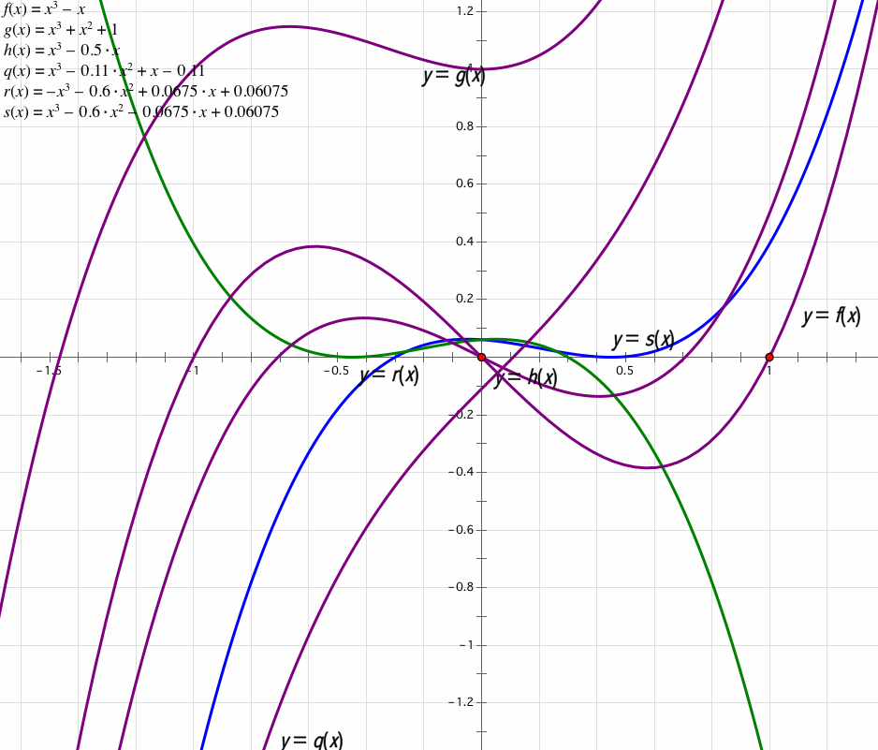

1 0 -1 0
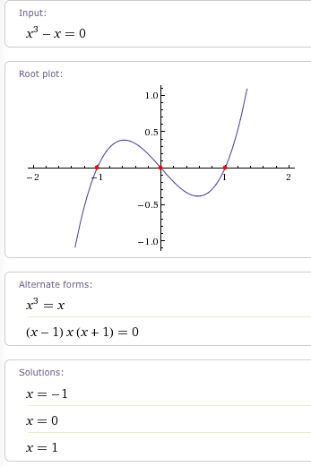
1 1 0 1
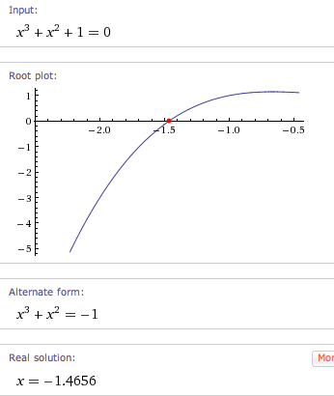
1 0 -0.5 0
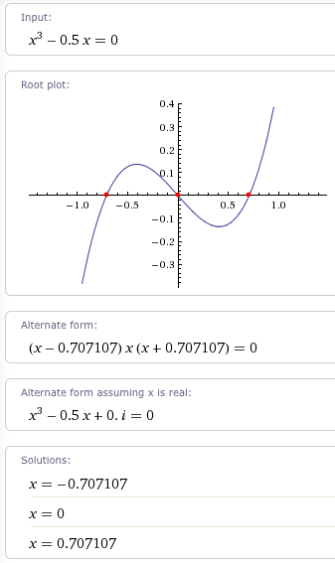
1 -0.8 1 -0.8
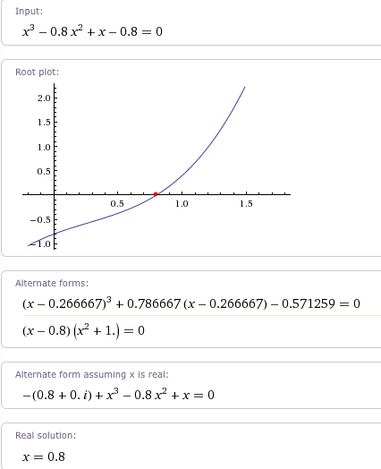
1 -0.11 1 -0.11
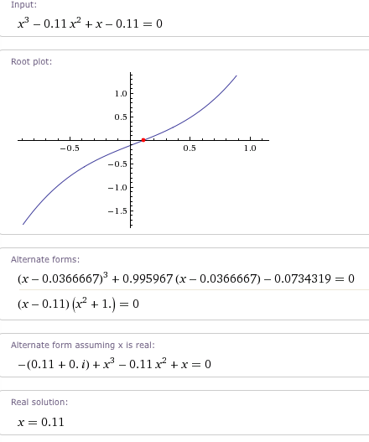
1 -1 1 -1
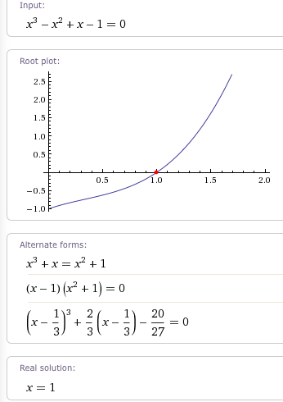
1 -8 1 5
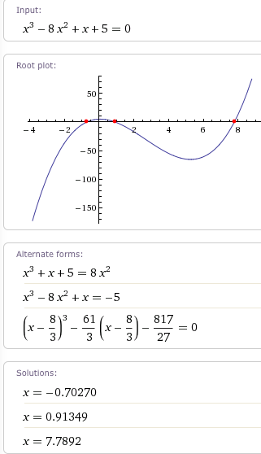

-1 2 0 -0.9
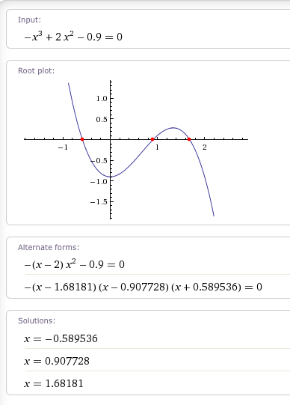
-1 4 0 -1
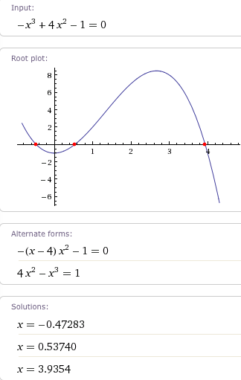
0 1 -0.9 0.2025 (quadratic)
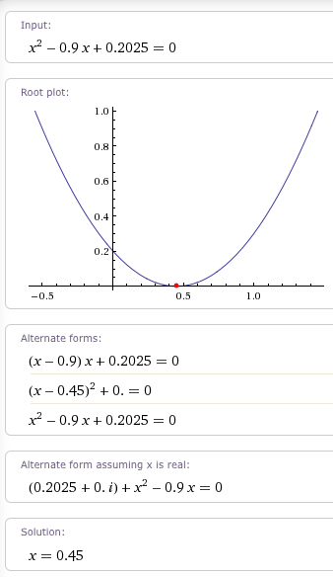
-1 -0.6 0.0675 0.06075
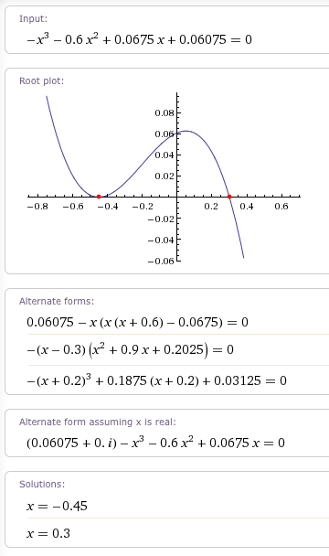
1 -0.6 -0.0675 0.06075
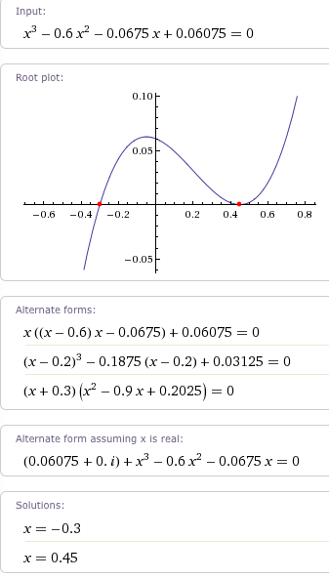
4 5 -1 -2
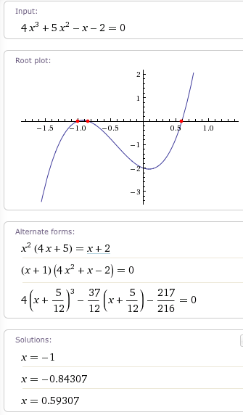
1 1 9 1
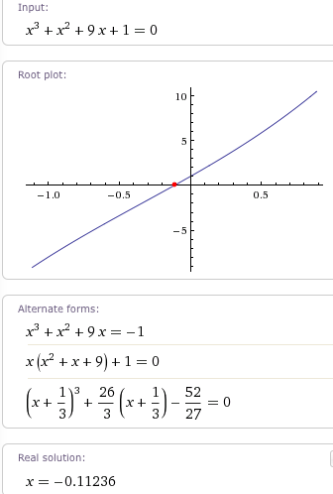

1 0.9996 0 0
