Greenfoot Project: “Amazing Game!”

Create a Greenfoot Scenario. This is your chance to show off your creativity and your unbelievable programming skills.

You will create a game (or simulation) from scratch using Greenfoot. What kind of game will you create? That’s up to you. Please don’t use the excuse, “I can’t think of anything.” You have played so many video games you are an expert!

Be as creative as you want. You may look at http://www.greenfoot.org/ to find ideas for scenarios, but of course you cannot copy the game completely. If you want to recreate a commercial video game that is fine, but you must check with the teacher first. Don’t attempt something that must be complicated in order to run at all.

All complex programs that run begin from a simple program that runs!

No nudity, killing of beings, or profanity.

Before you Begin: First, before you begin programming, you have to submit a paragraph with your idea before starting.

Time is of the essence. Creating a game can take awhile, especially the troubleshooting stage when you have to fix errors in your code.

This game will be due in two weeks. Check with the teacher for the due date.

Program Requirements: Look at the Rubric. Look at the Rubric. Again, look at the Rubric so you can get full credit.

Saving And Sharing Your File: When you are done, give a compressed (zipped) copy of your folder to the teacher via flash drive. Put the scenario on the Greenfoot site, http://www.greenfoot.org.
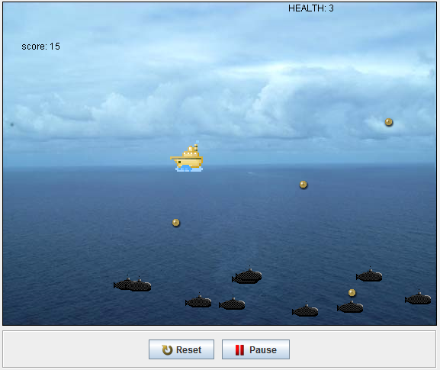

This is an example of a game. Use the left and right arrows and the spacebar.
Want to play it? Go to: http://greenfootgallery.org/scenarios/667

Help: Useful classes, including Mover, Counter and AnimatedActor can be found here: http://www.greenfoot.org/doc/support_classes
Name: ______________________________________________
 |  | Greenfoot Project Rubric | Max | Points
 |  | Required elements.
 |  | Actor and World Images  There are at least TWO Actor classes. The background fits with your game. | 10
 |  | Moving The Actor: movement( ) method  The protagonist class of the video game uses a method called movement( ) that is called in the act( ) method. This method contains the information for pressing keys, etc. | 10
 |  | Initializing Objects Upon Startup  The World subclass uses its constructor to create at least one object in the Greenfoot scenario upon initialization. | 5
 |  | Disappearing Objects  One of the actor objects in the world must disappear if it touches the edge of the world or touches another object. | 5
 |  | Keeping Score  Your scenario must have a scoring system. | 5
 |  | Game Over – Stopping the Scenario  The scenario must stop if a player loses or gets hit a certain number of times. | 5
 |  | Choose at least 2 of the following. Additional ones may be eligible for extra credit.
 |  | Checking for Collisions  Use a method called checkCollisions( ) somewhere in your Greenfoot scenario that checks to see if two objects are intersecting. | 5 or N/A
 |  | Displaying Score  Your Greenfoot scenario displays the score to the user. Check out the Counter class. | 5 or N/A
 |  | Precise Movement  More precise movement has been programmed into the game by flipping or rotating the actor to face the direction of movement. | 5 or N/A
 |  | More keys  Added keys beyond left and right. | 5 or N/A
 |  | Overall ratings.
 |  | Game Playability and Goal  The video game works. It must also be playable and easy to play. The game has a point and there is a clear goal. | 5
 |  | Code Quality  The class and method structure is organized and logical. Variable names make sense. | 5
 |  | Comments and Java Doc Comments  The programmer used appropriate comments and Java Doc comments in the code. | 5
 |  | Development Process  Key qualities: Planning (including the initial paragraph with the ideas), effort, independence, tireless bug finding, challenging yourself at your level. | 10
 |  | Difficulty and Complexity  Does it need if, for, and while statements, arrays, parameters, return types, or variables? Does it have complexity including many objects and methods? What level of design work is needed? | 20
 |  | Individuality  Did you copy code, modify it, and/or write it from scratch? | 5
 |  | Extra Credit (EC) ideas. Full credit only if the other parts of the code run well. Check with the teacher if other ideas qualify.
 |  | Animating Actors with different images that work together as frames of animation. | 2
 |  | Second player with a second set of keys/mouse. A special key for the other player.  Multiple lives. | 2
 |  | Exceptional craftsmanship in artwork and/or layout. | 2
 |  | Total | 100 + EC

