Sheet 0331: Useful Methods for Basic Programs Name: _______________

Methods for String Objects
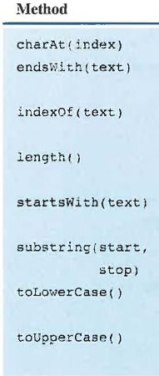

Scanner methods
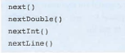
Methods in the Math class
